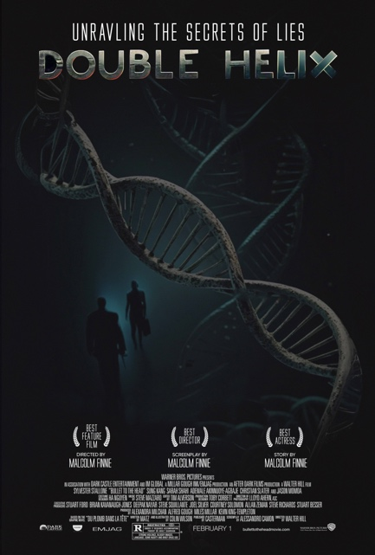

Title : DOUBLE HELIX
GENRE: DRAMA/CRIME/SUSPENSE
LOGLINE: When a desperate woman and her seasoned partner-in-crime hijack the DNA of a wealthy man, they set off a dangerous chain of events that entangle them in a deadly game of deception and betrayal.

Synopsis:

Double Helix is a drama/crime/suspense film that explores the dark side of identity theft and genetic manipulation. The film follows Jen, a financially struggling black woman, who teams up with Tom, a former geneticist turned criminal, to execute a daring plan: steal the identity and wealth of Jordan, a wealthy man with no family ties. Their modus operandi involves manipulating DNA results and orchestrating an elaborate con. However, their scheme unravels when Jordan discovers the truth and seeks revenge, while Detective Harris, a relentless investigator with a personal vendetta, closes in on them.

