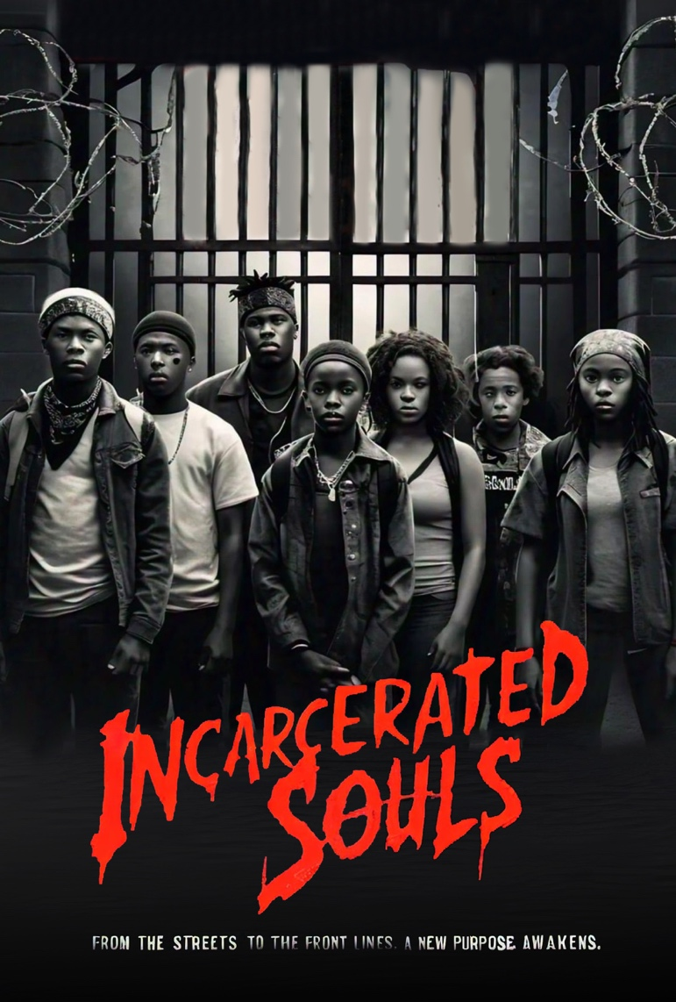

TITLE : INCARCERATED SOULS
GENRE: Thriller/Drama/Suspense/Action
LOGLINE:

SYNOPIS: A group of abandoned, outcast, and orphaned children, imprisoned in a secretive government facility, must navigate treacherous alliances and unravel dark secrets to escape a sinister government project that plans to exploit them as expendable soldiers. Within this secretive facility, eleven children, including one girl, are stripped of their identities and given nicknames reflecting their unique traits: Bear, Bay Bay, BJ, Chase, Snoop, G-Money, T-Bone, Snake, Smooth, C-Threw, and Switch. The project aims to transform them into ruthless and single-minded soldiers, drawing inspiration from the ferocity of New World army ants, Eciton burchellii. As they endure rigorous training, these children must confront the grim reality that their lives are expendable, destined to perish on their missions.

